Circuit Analysis (Lab4) Experiment4: Implementation of Basic Parallel Circuit

Name: Noor-ul-Ain Registration No: 2025-CE-83
Date: 27th March,2026. Grade and Signature:
CLO2  CLO3 | Use with identification the circuit components, breadboards, multimeters, power supplies, signal generators, and oscilloscopes.  Make measurements in their own constructed electric circuits.
Psychomotor/Affective | Level1  (1) | Level2  (2-3) | Level3  (4-5) | Level4  (6-7)
Report Marks(3) |  |  | Total marks(10)

Objectives: To make measurements in your own constructed parallel circuits.
Equipment required:
Power Supply, Breadboard, Connecting wires ,Resistances, Multimeter.

Lab Tasks:

  - Measure the current across R1, R2,R3 and Voltage between node 2 and 7.
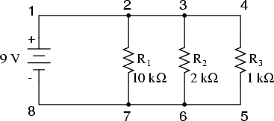
Practical Values:

R1 Current | R2 Current | R3 Current | Voltage
0.9mA | 4.50mA | 9.00mA | 9V

Theoretical Values:

R1 Current | R2 Current | R3 Current | Voltage
0.9mA | 4.50mA | 9.00mA | 9V

  - Measure the current across R1, R2,R3 and Voltage between node a and e.
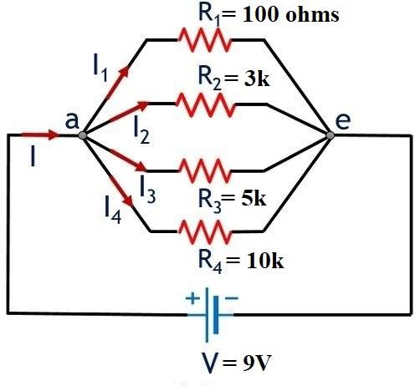

Practical Values:

R1 Current | R2 Current | R3 Current | R4 Current | Voltage
90.0mA | 3.00mA | 1.80mA | 0.90mA | 9V

Theoretical Values:

R1 Current | R2 Current | R3 Current | R4 Current | Voltage
90.0mA | 3.00mA | 1.80mA | 0.90mA | 9V

Post Lab Questions:
- Why is the value of voltage across each resistor in parallel circuit same?
Because all resistors are connected directly across the same two nodes of the power source.
In a parallel circuit:
- Every branch has the same starting point (positive terminal).
- Every branch has the same ending point (negative terminal).
Voltage is simply the potential difference between two points. Since each resistor connects across the same two points, the potential difference is identical.

]
- When parallel resistors are of three different values, which has the greatest power loss?
Power dissipated in a resistor:
P=V^2 /R
In parallel:
- Voltage across each resistor is same
- Power depends only on resistance

- How the current across any branch of a parallel circuit varies?
Current in each branch follows Ohm’s Law:
I=V/R
Since voltage is constant:
- Lower resistance → higher current
- Higher resistance → lower current
So current divides inversely proportional to resistance.

- What happens to total resistance in a circuit with parallel resistors if one of them opens (i.e.,removed)?
When a branch opens:
That path for current disappears.

Result:
- Total resistance increases
- Total current drawn from source decreases
- Remaining branches still get same voltage
Why?
Parallel resistance formula:
1/RT=1/R1+1/R2+1/R3+​
Removing one resistor removes one term → reciprocal becomes smaller → total resistance becomes larger.

